RESOLUTION NO.__________

RE: CERTIFICATE OF APPROPRIATENESS UNDER THE
PROVISIONS OF THE ACT OF THE PENNSYLVANIA
LEGISLATURE 1961, JUNE 13, P.L. 282 (53
SECTION 8004) AND BETHLEHEM ORDINANCE NO.
3952 AS AMENDED.

WHEREAS, it is proposed to install a new sign on an existing bracket at 451 Main St. (The Flying Egg)

NOW, THEREFORE, BE IT RESOLVED by the Council of the City of Bethlehem that a Certificate of Appropriateness is hereby granted for the proposal.

Sponsored by: (s)

(s)

ADOPTED BY COUNCIL THIS DAY OF

(s)
President of Council

ATTEST:

(s)
City Clerk

HISTORICAL & ARCHITECTURAL REVIEW BOARD

The applicant is proposing to install a new sign on an existing bracket at 451 Main St. (The Flying Egg)
APPLICATION #2A:

Tony Mauser
451 Main St.
Bethlehem, PA 18018

OWNER:

__________________________________________________________________________

The Board adopted the proposal that City Council issue a Certificate of Appropriateness for the following:

- Install a new oval shaped sign on MDF foam board.
- White background/black pinstripe.
- Simple black chain to connect existing bracket to sign
5. The motion was unanimously approved.
__________________________________________________________________________

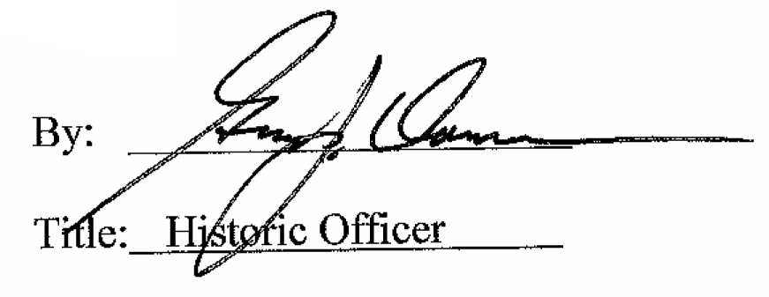

Date of Meeting: April 5, 2017

